When a user first navigates to our site, they will be presented with a large map, year selections, and data selections:

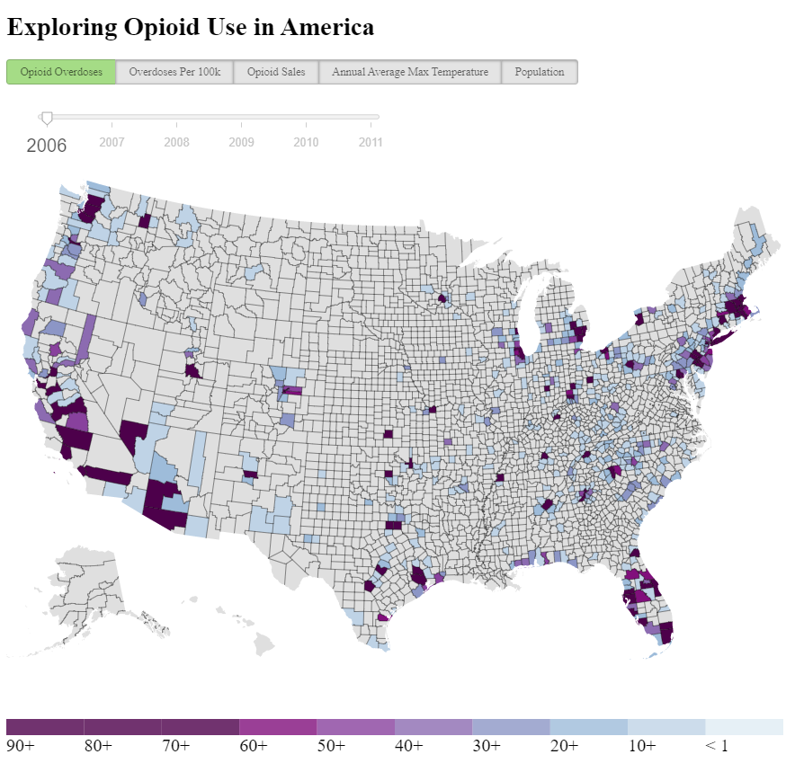

The user will then select a dataset and year that they would like to examine. Upon hovering over a county a tooltip will display that provides the county name, state, and value of the current dataset they are viewing. If the user selects a county a menu to the right of the map will displaying, allowing the user to drilldown further into the data:

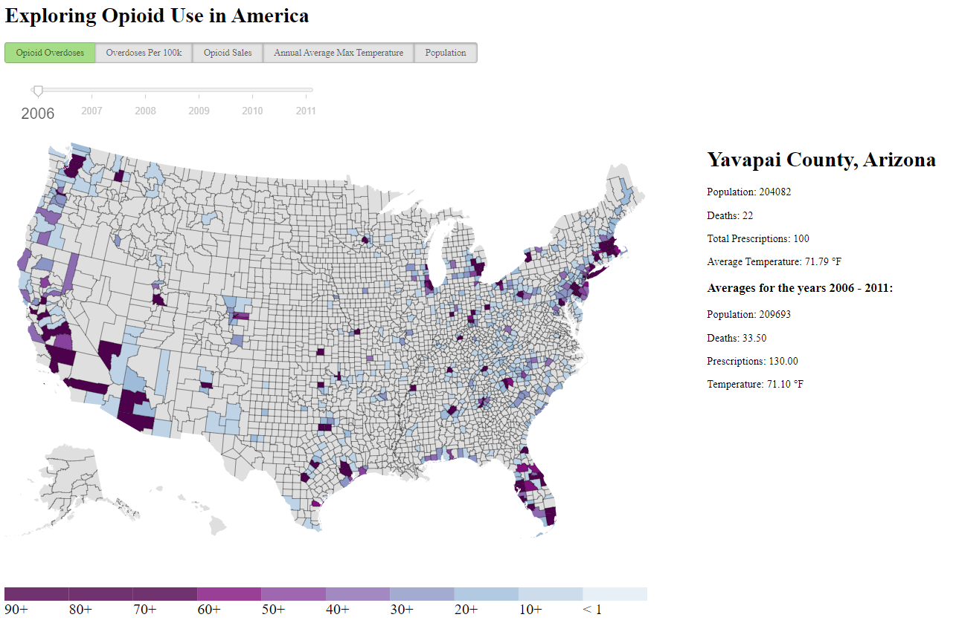

Here is a closer look of what the user can expect to see:

Directly under the county name and state name, there is a list that contains the population, deaths, total prescriptions, and average temperature in degrees Fahrenheit for the currently selected year. Beneath this, the user can see an average of population, deaths, prescriptions, and temperature for the years 2006-2011.

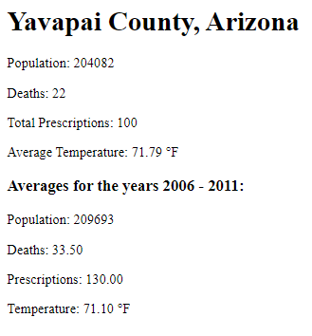

Additionally, the user will see a bar chart that appears next to the data drilldown. This bar chart shows the ranking of the currently selected county to the rank of similar counties within the U.S. There are 5